Project Reporting Structure Outline

DS 6999 Independent Study

Tommy Jun, Sean Mullane, Sri Vaishnavi

Background

This section will serve as a brief introduction discussing the background of the project and mentions of similar work done previously.

Data Processing

This section will include a description of what processing we applied to the data.

Top Line Results

This section will include tables of results (accuracy metric) for each frequency and window size along with the standard deviation of each cell in the table.

Example table:

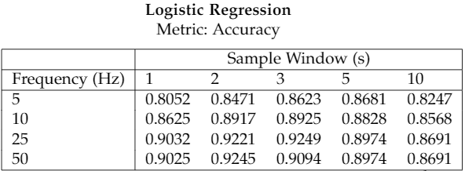

Analysis of Results

This section will include a statistical analysis of the accuracy values for the models in each cell with a significance test to determine whether the mean accuracy of the best model is statistically significantly greater than the lesser models. We will attempt to apply a similar test to that used in the Niazi Master’s thesis.

Discussion

This section will include a discussion of results including factors that may explain the results seen and notable issues encountered during data preparation.